Simulation study protocol – Breakpoints’ distribution
This document aims at explaining preliminary choices of breakpoints in the simulation study.
See R script at /github/mixedBreak/test/distrib-breaks.R

One of the main goals of the simulation study is to generate fictive patients to benefit from having a large amount of data for model evaluation. But most importantly, we need to generate patient that looks like real patients, up to a certain noise level that we can control.
A modelling choice was made based the characteristic reported in Stenbæck et al. (https://journals.sagepub.com/doi/10.1177/0269881120959609). By reproducing the analysis described in this article, we can then base the simulation means and noise level on the following results (mean (sd) [range] in minutes after drug intake):
- Breakpoint 1: 77.2 (38.2) [32.5 ; 157.9]
- Breakpoint 2 – breakpoint 1: 77.5 (33.3) [29.0 ; 142.8]
- Breakpoint 3 – breakpoint 2: 131.6 (39.3) [90.0 ; 204.1]
Modelling distance with a lognormal distribution allow to avoid using rejection sampling. The major drawback is that since breakpoint time-coordinates are simulated independently, the variance stacks up, resulting in higher time variability in later breakpoints:
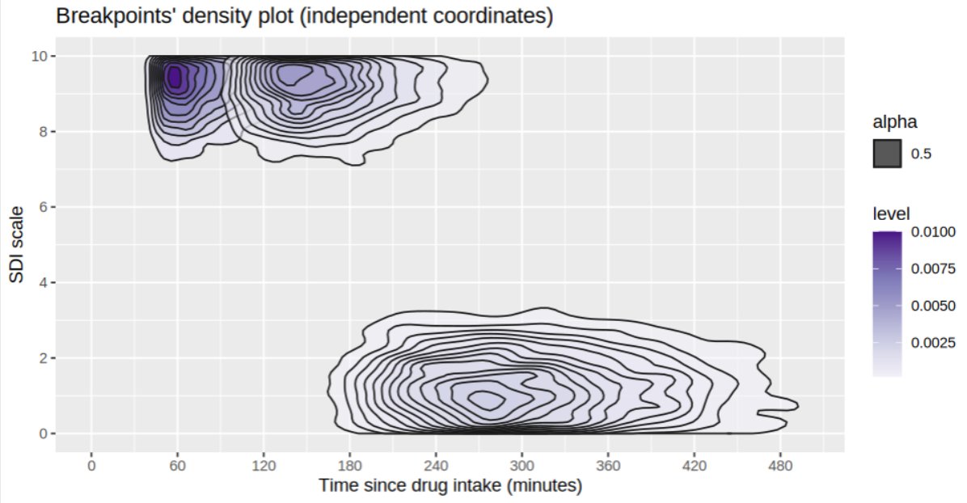
Figure 1 - Breakpoints density plot (n=5000)

Specifying a multivariate gaussian breakpoint distribution
- Correlation helps specifying the mean of ratio Y/X (see full details at /student/noahdegoulange/github/mixedBreak/test/distrib-breaks.R) but only under certain conditions on the scale parameters of the ratio Y/X

